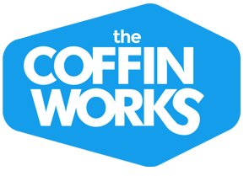

www.birminghamconservationtrust.org
www.coffinworks.org

The Coffin Works, 13-15 Fleet Street, Jewellery Quarter, Birmingham, B3 1JP
0121 233 4785 josie@coffinworks.org
facebook: /thecoffinworks twitter: @CoffinWorks Instagram: @coffin_works

Group Booking Form
Please contact us to check availability and then complete the form below and return to the address above, with a £15 deposit* (remainder of visit fee payable on the day, groups must pay together to receive the group rate of £5), cheques made payable to Birmingham Conservation Trust.

Group/Society Name

Preferred date of visit

Preferred time of tour: 11am, 12pm, 1pm, 2pm or 3pm. Out-of-hours (please request time).
Organiser Name

Contact Telephone Number and/or email
Contact Address
Number of people in group
(groups larger than 15 will be split into multiple tours – we can devise an itinerary to suit)
Are refreshments required (an extra £1.50 per head)?
Lunch deal at Shakespeare Inn (an extra £7 per head)?
Do any of your group have any mobility or other needs?
How did you hear of the Coffin Works?
*Receipt of the non-refundable deposit guarantees your exclusive tour on the time/date you have specified.
Out of hours tours can be arranged at a higher cost of £8 per head. This includes tours on Mondays and Tuesdays when the museum is normally closed to the public. Please contact the group tour organiser to arrange.
When you share your personal data with us, we treat it with care and take our responsibility to protect it seriously (Birmingham Conservation Trust will never sell your data to a 3rd party.) Information about your booking may be shared with partner organisations e.g. Shakespeare Inn in order to provide your group with the best experience. Full details on how Birmingham Conservation Trust stores and processes your data can be found in our Privacy Policy.
Group photographs may be taken during tours for use on our social media and websites, which are listed in the header of this booking form. Please inform a member of the team if you do not wish your photo to be used.

