Collections Development Policy  including Acquisition & Disposal Policy  Newman Brothers at the Coffin Works, Birmingham Conservation Trust | 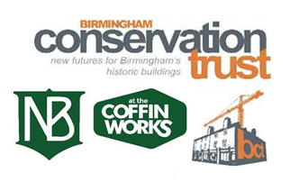

Creation date: | June 2017
Creators: | Museum Manager and Head of Coffin Works’ Committee
Review date: | June 2020
Reviewers: | Museum Manager and Coffin Works’ Committee

POLICY CONTENTS
- Mission statement of Birmingham Conservation Trust | 2
- Introduction | 2
- Acquisition guidelines | 2
- Limitation on collecting | 5
- Ownership & title | 5
- Disposal guidelines | 6
Appendix A: Register of Title Report provided by Land Registry, 28 Jan 2010 | 7
Appendix B: Extract from Report on Title prepared by Lodders Solicitors, 29 July 2010 | 10
Appendix C: Extract from Transfer of Title from Advantage West Midlands to Birmingham Conservation Trust, 1 June 2010 | 14

1. Mission Statement of Birmingham Conservation Trust
Returning historic buildings to a place in people’s lives
 | 1.1 | We believe that sharing the past creates a sense of community and identity today. We will use our roots in the industrial and manufacturing history of the Jewellery Quarter and our links to its contemporary communities and partnerships to engage and involve people in the long-term development of Newman Brothers situated at The Coffin Works.

2. Introduction
 | 2.1 | This policy is intended to regulate the acquisition and disposal of objects for Newman Brothers at the Coffin Works, 13-15 Fleet Street, Jewellery Quarter, Birmingham, owned by Birmingham Conservation Trust (hereafter referred to as BCT). It has been developed in conjunction with the support and advice of a select group of Trustees from Birmingham Conservation Trust.
 | 2.2 | The period covered by this policy encompasses the development of the heritage spaces at Newman Brothers at the Coffin Works, its opening to the public in Autumn 2014 and its first 6 months of operation as a heritage attraction. It is intended to support the assessment, selection, retention and disposal of the contents of Newman Brothers that were inventoried and removed from the building in 2007.

3. Acquisition Guidelines
 | 3.1 | Policy statement: A core collection will be developed to represent the history of Newman Brothers during their time in business between 1894-1999. Only objects from the original inventory, items manufactured by Newman Brothers or associated with individuals who worked at or for Newman Brothers between 1894-1999 will form part of the core collection.
 |  | 3.1.1 | Process: The Collections & Exhibitions Manager will, through research, identify the Newman Brothers’ core collection, those objects vital to retain to represent the history of the factory between 1894-1999.
 |  | 3.1.2 | Although many core collection objects will have been identified by the time the heritage attraction opens in October 2014, it is anticipated that a period of on-going research will continue thereafter, which may result in more objects entering the core collection, and in some cases being transferred from display and handling collections. It is intended that, unless essential to the interpretation of the heritage spaces, core collection objects will be kept in storage and used for research purposes to develop collections knowledge.
 |  | 3.1.3 | The core collection will be formally accessioned and renumbered. Information concerning each object will be added to the collections database, Adlib, in the form of new records. The original Ironbridge catalogue numbers associated with each object will be retained in each new record, along with new accession numbers.
 | 3.2 | Policy Statement: A display collection will be selected to dress the heritage spaces using the original contents of the building, to aid the various rooms’ interpretation.
 |  | 3.2.1 | Process: In addition to the core collection, objects will be selected and eventually accessioned into a display collection. Initially, due to time constraints, only the core collection will be accessioned, but it is anticipated that formal accessioning of the display collection will begin from November 2014 onwards to aid Accreditation. These spaces specifically include the Stamp Room, Warehouse, Shroud Room, Large Office and Post Room/Metal Store.
 |  | 3.2.2 | The display collection will consist largely of expendable or sacrificial objects. Where possible, a number of duplicate objects will be kept in storage, which can be displayed at a later date or on a rotation basis. The Collections Care Policy outlines further details on how objects will be cared for while in storage and on display.
 |  | 3.2.3 | The display collection will be strongly dictated by the museum interpretation plan, which provides guidelines for how The Newman Brothers at the Coffin Works should be ‘dressed’, identifying the 1960s as a period-setting for the interpretation. This facilitates the object selection process since objects dating from that period and before will be given special consideration in order to fulfil interpretation criteria.
 |  |  | 3.2.3.1 | The mid 1960s has been selected as the period-setting since it represents the last major period of growth and development for Newman Brothers' business. Much of the Large Office furniture dates from this period and it appears that little re-decoration or equipment renewal took place after this date.
 |  |  | 3.2.3.2 | Whilst much of the factory equipment may be found to date from before 1965, there is not enough in the collection, or indeed of the building fabric, to provide material for a complete presentation of the factory as it would have been at a different, earlier period (i.e. for 1890s, First World War etc).
 |  | 3.2.4 | Objects of important merit outside the period of interpretation (1960s) shall be retained, and in some instances, such as in the case of the company business archive, shall be formally accessioned into the core collection.
 |  | 3.2.5 | Objects of important merit outside the period of interpretation (1960s) shall be retained, and in some instances, such as in the case of the company business archive, shall be formally accessioned into the core collection.
 |  | 3.2.6 | In line with our Data Protection policy, the display collection will not include any items containing sensitive personal information about identifiable individuals, created within 100 years of the start of the current year, without the permission of that individual or their direct* descendants.
 | 3.3 | Policy Statement: A handling collection will be selected to support learning and engagement in Newman Brothers.
 |  | 3.3.1 | Process: Handling objects will be selected on the basis of their ability to tell Newman Brothers’ history, in line with curricular and subject themes within the collection, as well as being robust enough to withstand regular handling by school groups and visitors. The Collections & Exhibitions Manager will advise on the selection in conjunction with the Learning Manager.
 |  | 3.3.2 | The handling collection will retain its original Ironbridge inventory numbers and will not be formally accessioned.
 |  | 3.3.3 | In line with our Data Protection policy, the handling collection will not include any items containing sensitive personal information about identifiable individuals, created within 100 years of the start of the current year, without the permission of that individual or their direct descendants.
 | 3.4 | Policy Statement: BCT does not intend actively to collect during the period of this policy.
 |  | 3.4.1 | Process: If objects become available that are of special significance to the history of Newman Brothers and the existing collection, especially archival material, industry-trade catalogues, photographs of individuals associated with Newman Brothers etc, then priority will be given to acquiring them for the core collection.
 |  | 3.4.2 | The Collections & Exhibitions Manager will consult with relevant Trustees from BCT before any decision to acquire an object is taken. Decisions to acquire objects will be based on the ability to secure legal title to the item in question.
 |  | 3.4.3 | BCT will not acquire any object unless the Collections & Exhibitions Manager can secure provenance for the item and is satisfied that it can be legally acquired. BCT will exercise due diligence and make every effort not to acquire, whether by purchase, gift or bequest, any object whose provenance cannot be confidently established.
 |  | 3.4.4 | The Collections & Exhibitions Manager will, where possible, ensure that the acquisition and addition of any material to the Collections includes copyright for use in any promotional and marketing material.
 |  |  | 3.4.4.1 | Visitors to Newman Brothers at the Coffin Works will be permitted to take photographs during their visit for their own personal or educational/research use.
 |  |  | 3.4.4.2 | Photographers and film-makers wishing to create images in the attraction for commercial use will be subject to a licensing agreement which may include restrictions upon what they may photograph. This will be determined by the Collections & Exhibitions Manager.
 |  |  | 3.4.4.3 | As far as possible, the display collection will not include any original material for which we do not own the copyright. In instances where we include display material for which we do not own the copyright (e.g. commercial packaging or press cuttings) we shall attempt to present it in such a way that it is compliant with educational and research use.
 |  |  | 3.4.4.4 | An Intellectual Property & Reproduction Rights policy will be drawn up and will address regulation of the reproduction of images by researchers, commercial users and general visitors.
 |  | 3.4.5 | BCT will not acquire excavated material in any case where the Collections & Exhibitions Manager and acquisitions committee have any suspicion that the circumstances of their recovery involved a failure to follow appropriate legal procedures involving reporting finds or securing permission from the owner and/or occupier of the land. If material relating to other BCT projects is offered, these enquiries will be passed to the Board of Trustees for referral to other appropriate bodies.
 |  | 3.4.6 | BCT will only collect archive material relating to Newman Brothers. However, we will refer potential donors of unrelated material to the relevant repository such as Birmingham Archives and Heritage located at the Library of Birmingham.
 |  | 3.4.7 | BCT will not accept donations or loans to which special conditions are attached.
 |  | 3.4.8 | Objects requiring conservation treatment prior to entry into the core collection will be considered in conjunction with estimated costs and affordability of any conservation treatment deemed necessary.

4. Limitation on collecting
 | 4.1 | BCT will take into account limitations on collecting based on its ability to provide appropriate storage and care of collections for Newman Brothers at the Coffin Works. If, therefore, appropriate storage, security and collections care cannot be guaranteed, items will not be acquired. Every effort will be made to refer prospective donors to other relevant archives and organisations.

5. Ownership and title
 | 5.1 | BCT will take into account limitations on collecting based on its ability to provide appropriate storage and care of collections for Newman Brothers at the Coffin Works. If, therefore, appropriate storage, security and collections care cannot be guaranteed, items will not be acquired. Every effort will be made to refer prospective donors to other relevant archives and organisations.
 | 5.2 | Due to the lack of storage space at The Coffin Works, a large proportion of the original contents of Newman Brothers are scheduled for disposal. BCT holds title to these items as a result of the sale of Newman Brothers from Miss Joyce Julia Green to Advantage West Midlands (AWM), and the subsequent sale from AWM to BCT. Please refer to page 2 of 2 in the Register of Title report (Appendix A), for further details on the purchase of Newman Brothers from Miss Joyce Julia Green to Advantage West Midlands on 14 June 2003..
 | 5.3 | The report notes on page 2 of 2 that there are ‘restrictive covenants’ included in the purchase of the building. These covenants can be found in section 3.7.2 on page 4 of the Report on Title, (Appendix B) prepared by Lodders Solicitors. They state that the property is not to be used for residential purposes for a period of five years from the date of purchase. The restrictions are, therefore, no longer applicable and do not impact on the right to dispose of contents.
 | 5.4 | The transfer of ownership from AWM to BCT is outlined on page 14 in the British Property Register contract regarding the Transfer of Title (Appendix C). In addition, that contract also confirms the right of BCT to dispose any contents purchased with the building from AWM on 1 June 2010. It is summarised below:
 | 5.5 | "All former contents of the property are stored off-site under the control of the buyer. Such contents are included in the purchase price agreed for the transaction."

6. Disposal Guidelines
 | 6.1 | Once objects have been selected for disposal, the proposals will pass to a sub-group of relevant Trustees for initial approval, which will then, in addition, require written authorisation from the Board of Trustees for formal approval to dispose.
 | 6.2 | Disposal of contents will, in part, be governed by the Disposal Toolkit produced by the Museum Association where appropriate. However, as a core collection has not yet been selected or accessioned, some of these guidelines are not applicable.
 |  | 6.2.1 | The categories of items deemed suitable for disposal are:
 |  | 6.2.2 | - Duplicate items. A selection will be used in handling collections which are intended for use in schools or other public engagement activities.
 |  | 6.2.3 | - Dangerous or hazardous items. Any product that is deemed dangerous or which poses a potential health hazard will be disposed of via an appropriate and safe method.
 |  | 6.2.4 | - Surplus duplicate items of ‘saleable’ merit. For example, complete boxes of coffin handles and other coffin furniture. In the first instance these will be offered for sale to funeral directors; and relevant religious organisations or affiliated businesses such as cathedral gift shops in Birmingham. A selection of suitable Newman Brothers products will also be sold on site in the museum shop, once operational in October 2014.
 |  | 6.2.5 | - Damaged or surplus items. For example used sheet or pierced metal. These will be sold as scrap or otherwise disposed of.
 |  | 6.2.6 | - Unusable objects. Any object which is ‘unusable’, meaning it is a miscellaneous fixture or one that has no historic merit in advancing the understanding of Newman Brothers’ history, will be disposed of.
 | 6.3 | Policy Statement: Proceeds from sale of objects will be ring-fenced in BCT accounts for the development and care of collections at Newman Brothers at the Coffin Works.

Appendix A: Register of Title Report provided by Land Registry, 28 Jan 2010
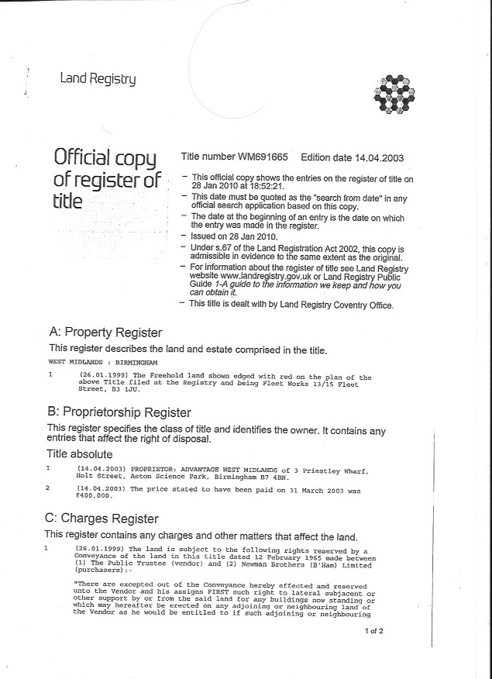

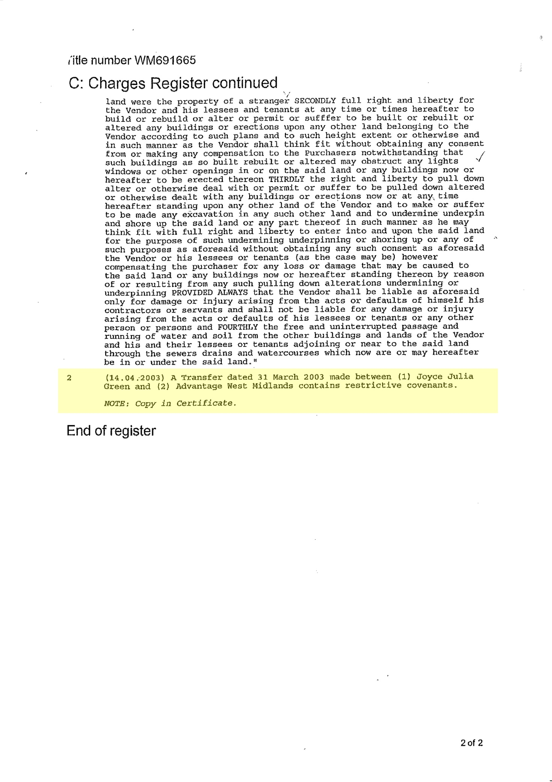

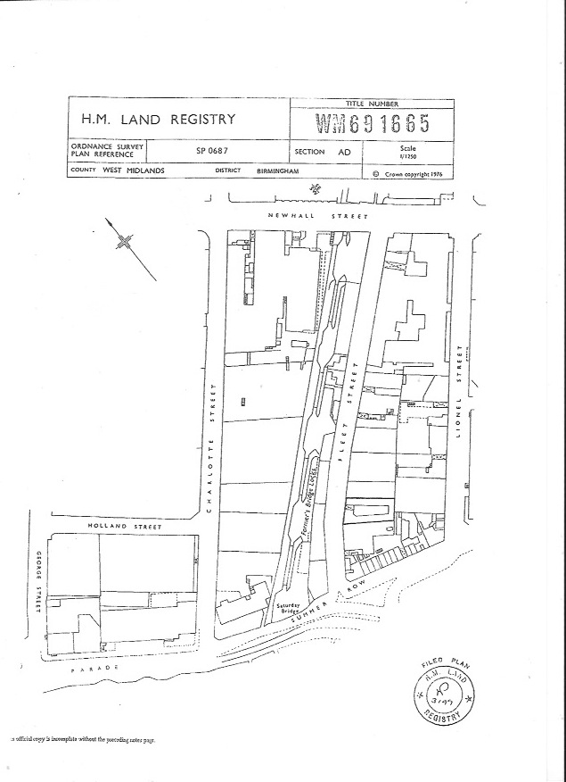

Appendix B: Extract from report on title prepared by Lodders Solicitors, 29 July 2010
This extract relates directly to BCT's claim to the title of the Newman Brothers at the Coffin Works Collections. For access to the full document, please contact the Director of BCT.
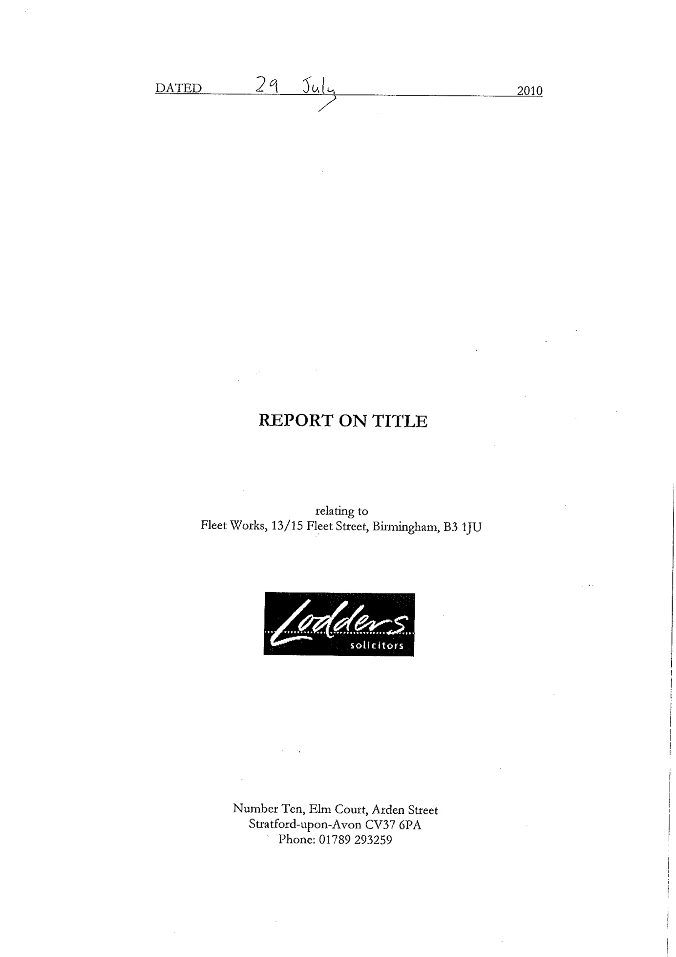
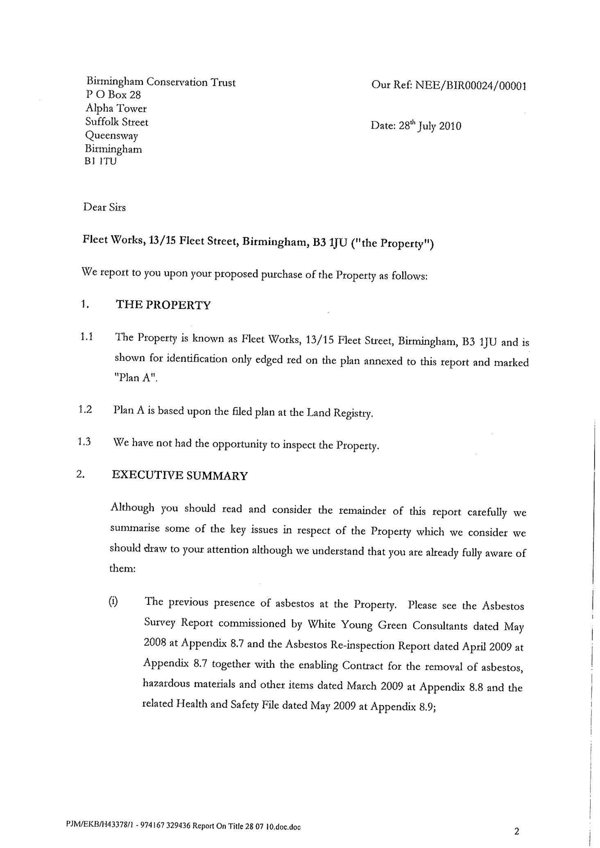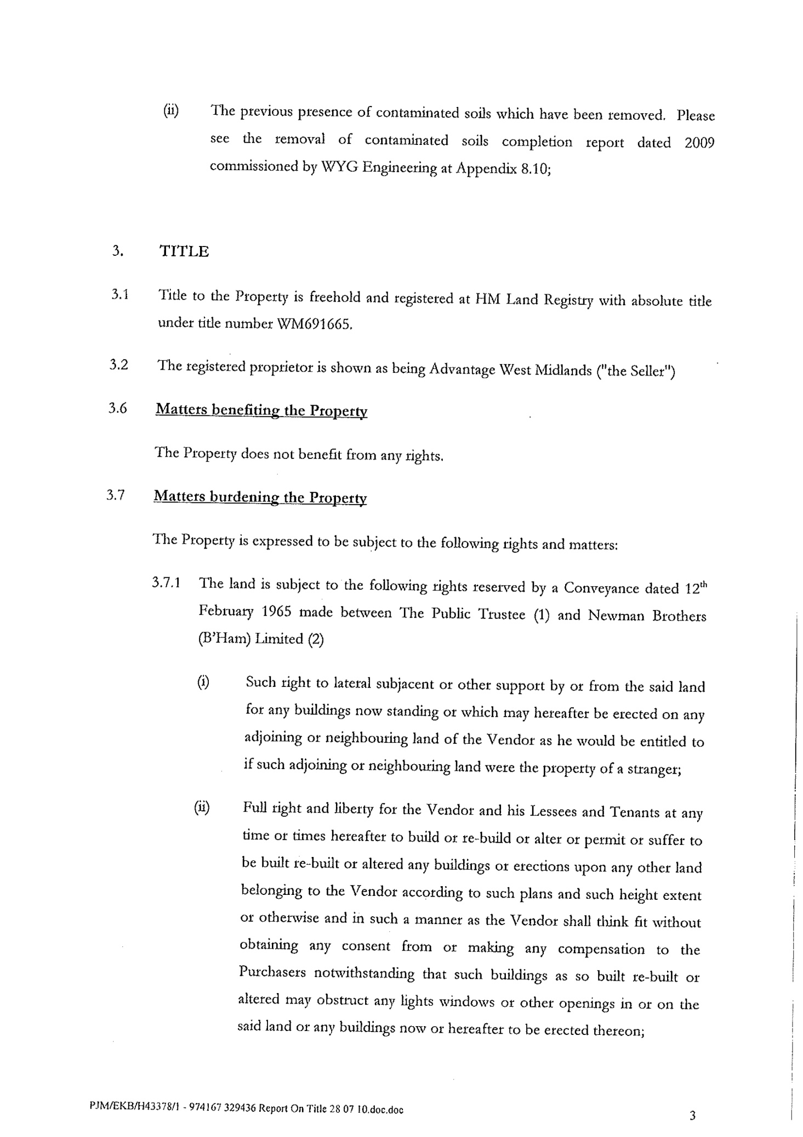
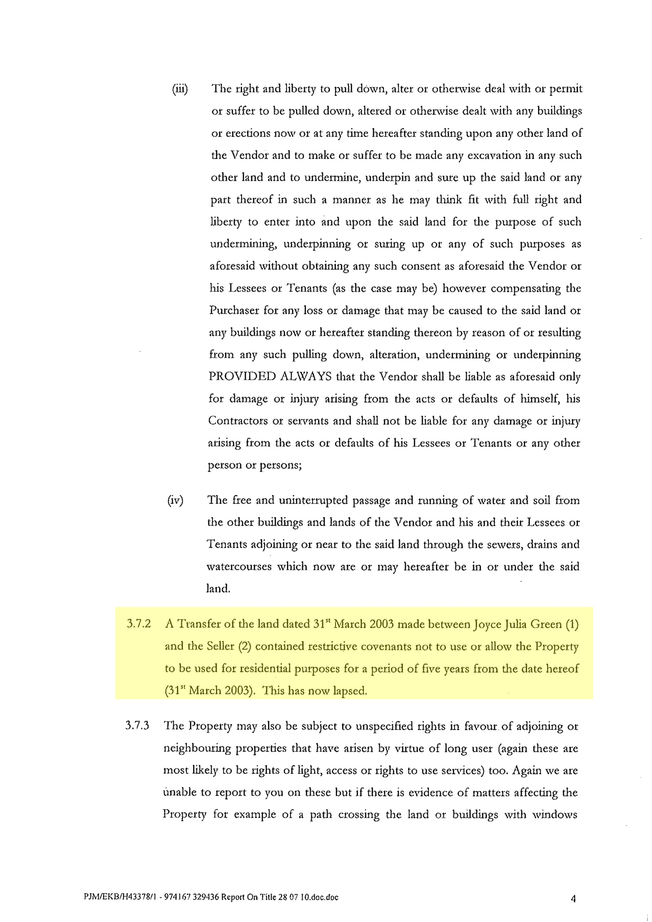
Appendix C: Extract from Transfer of Title from Advantage West Midlands to Birmingham Conservation Trust, 1 June 2010
This extract relates directly to BCT's claim to the title of the Newman Brothers at the Coffin Works Collections. For access to the full document, please contact the Director of BCT.
