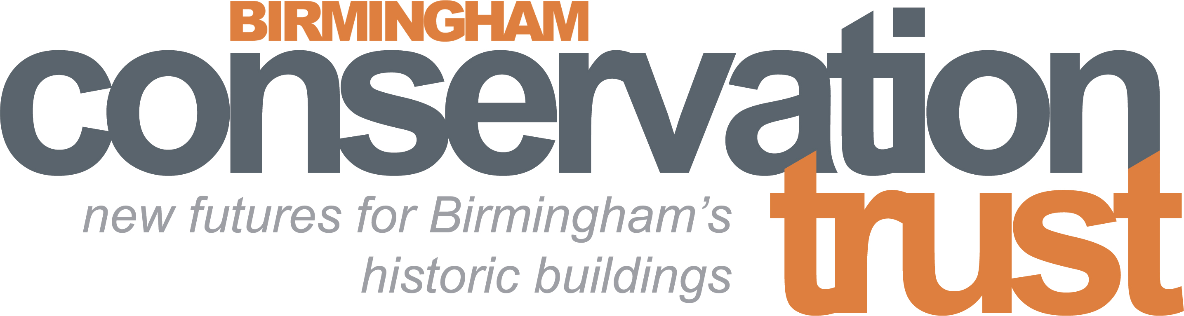
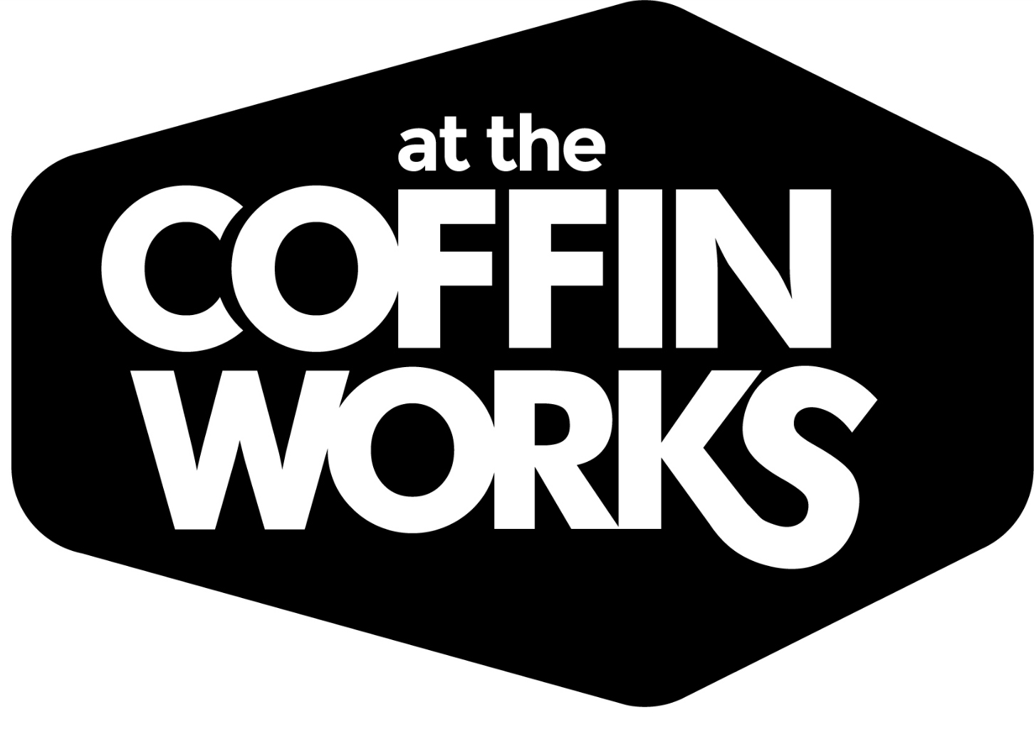


Coffin Works’ Volunteer & Operations Assistant
Job Description

Job Title | Volunteer & Operations Assistant
Working days and times | Every other weekend and every other Friday 9.45am – 4.45pm (7 hours) with a paid 20 min rest break (to be taken onsite). Some additional ad-hoc shifts to cover holidays and events may be available.  This role is a two-year fixed term position, with 6-months’ probation.
Work location | The Coffin Works, Fleet Street, Jewellery Quarter, Birmingham, B3 1JP
Organisation Name | Birmingham Conservation Trust
Salary | £9.23/hour. (Equivalent to salary of £18,000 pro rata)
Annual leave | Your holiday entitlement per annum will be 25 days pro rata, which equates to 7 days per annum. You will also be entitled to 2.25 bank holidays per year. All staff are required to book annual leave for any normal working days when the museum is closed over the Christmas period.
We need a Volunteer & Operations Assistant to act as Duty Manager to supervise volunteers and the operations of the Coffin Works’ site during every other weekend and every other Friday. As Duty Manager you will be a key holder with responsibility for the smooth running of the Newman Brothers’ Museum and the wider Coffin Works facilities. You will be a self-starter and people person.

Volunteers
Key tasks and responsibilities:
- Support and recruitment of volunteers, working with the Coffin Works’ team to identify further volunteering tasks
- Assist delivery of the induction programme and support ongoing volunteer performance reviews to ensure Health and Safety and GDPR requirements are met
- Manage the volunteer rota for the museum, ensuring cover is maintained for opening hours and special events etc.
- Help us to review, recognise, reward and retain our volunteers
- Help plan and implement suitable and necessary training programmes for volunteers at the Coffin Works

Museum Operations
Key tasks and responsibilities:
- Prepare the museum/site ready for opening including: switching on lights and sound effects, setting up the till and refreshing the Waiting Room facilities
- Supervise, motivating and supporting our Front of House and Tour Guide volunteers; providing break cover and additional training where necessary. You will always be at the end of the radio and available to operate the drop stamp if volunteers are not trained (you will receive training in these tasks)
- Answer visitor enquiries in person and on the phone; dealing professionally and effectively with any customer complaints or concerns
- Supervise any meetings or events booked during the day and occasionally during the evening (some occasional evening working will be required)
- Cover shifts where no volunteers are available to ensure the smooth operation of the museum. You will be fully trained in all roles including delivering guided tours to a high standard
- Ensure Waiting Room facilities, family activity resources, feedback forms and leaflets are always topped up and available
- Use social media to communicate with our followers about interesting ‘live’ things happening or events coming up
- Use your time productively during quiet times by developing the museum’s on-line promotional and marketing activity
- Produce leaflets and any relevant literature to promote activities on site
- Update the museum website with events listings where appropriate
- Cash up and keep financial records at the end of the day
- Contact volunteers to fill gaps in the rota
- Close down the museum, switching off lights and locking up.

Coffin Works’ Operations
Key tasks and responsibilities:
- Carry out weekly basic maintenance tasks which include: sweeping the courtyard, clearing the drains of leaves, litter picking, putting out the bins and keeping the store rooms tidy
- Check and clean toilets regularly to ensure a high standard of presentation and hygiene for visitors
- Act as the responsible First Aider on site (training provided)
- Ensure that you adhere to Health & Safety and emergency plans for the site
- Carry out security checks of the property, ensuring that CCTV is operational and the alarm is put on when you lock up
- Answer the telephone and redirect queries as appropriate to other staff members
- Act as the point of contact for our tenants and, where possible, help to resolve any issues
- Report by email at the end of each day to the Museum Manager on the day’s activities and any issues or work which need attention
- Carry out other realistic tasks as directed by the Museum Manager

Relationships
- The postholder will be line managed by the Coffin Works and Museum Manager.
- You will work closely with other members of the Coffin Works’ team.

General
Training will be provided in specific areas as necessary, including but not limited to:
- Operation of the till system
- Safe operation of historic machinery
- Tour guiding
- First Aid
- GDPR
Person Specification
You will be full of energy, customer-focussed and practical with great communication and people skills, and a mature and common sense approach to work.
Experience and Knowledge
Essential
- Experience of working (paid or unpaid) in a customer-focused role in a visitor attraction, museum or similar
- Experience of giving tours and/or talks
- Experience of supervising staff or volunteers
- Experience of managing rota system
- Experience of keyholding
- Excellent team working skills
- Experience of retail, including cash handling
- Knowledge and enthusiasm for industrial, social or urban history and heritage
- Knowledge of the heritage/visitor attraction/tourism industry
Skills and Abilities
Essential
- Excellent people and communication skills
- Initiative and common sense approach to resolving problems
- Ability to diffuse difficult situations and stay calm under pressure
- Competency with Office IT packages, email and social media
- Confidence and ability to lead tours and to demonstrate drop stamp machinery for visitors (drop stamp training provided)
- Task driven and ability to work enthusiastically
- Self confidence in dealing with people of all ages and all abilities
- Discretion in handling situations and material in a confidential way to ensure GDPR compliance
Education and Qualifications
Essential
Good standard of general education, with qualifications in Maths and English at GCSE/O’Level at grade C or above.
Deadline for applications is 5pm on Tuesday 24th July, with interviews taking place on Monday 30th July.
Applications should be sent to Sarah Hayes: sarah@coffinworks.org
Informal enquiries should be sent to sarah@coffinworks.org or call on 0121 233 4785.

