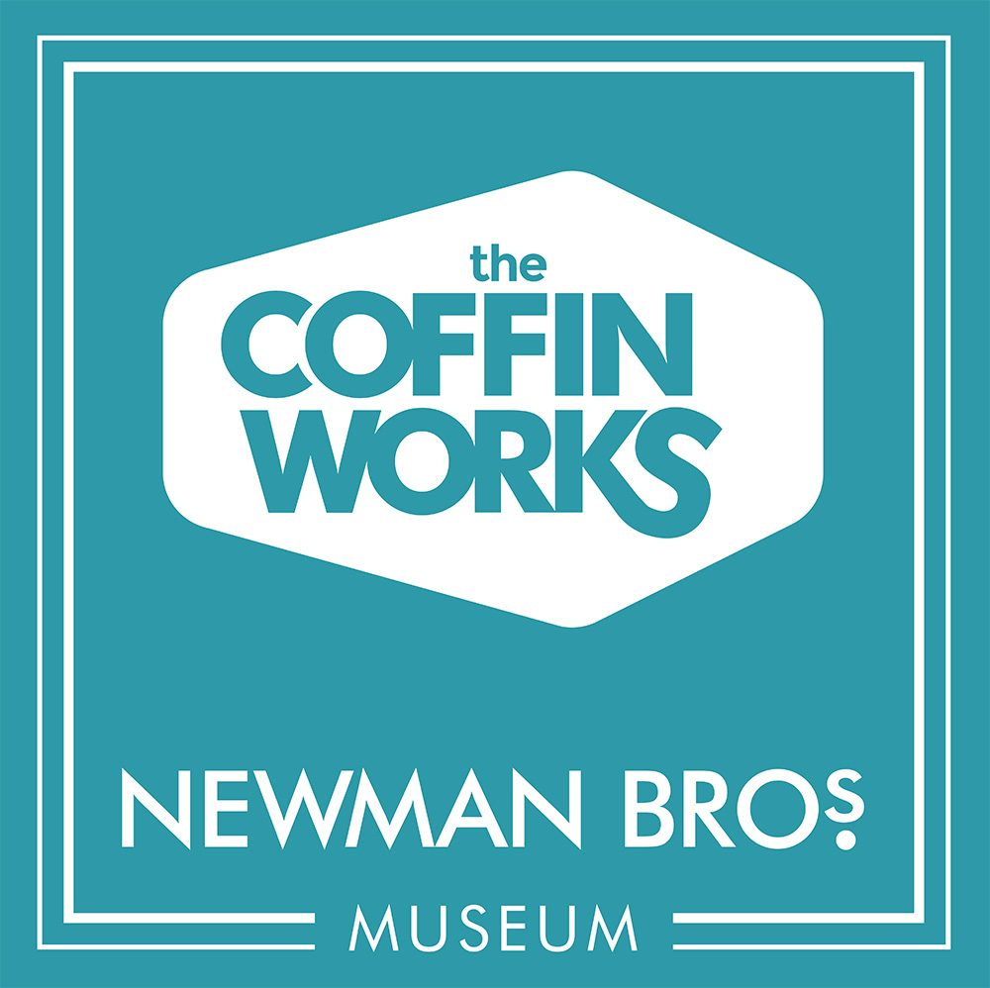

The Coffin Works, 13-15 Fleet Street, Jewellery Quarter, Birmingham, B3 1JP

0121 233 4785

[newmanbrothers@coffinworks.org](mailto:newmanbrothers@coffinworks.org)

[www.coffinworks.org](http://www.coffinworks.org)

**Meeting Room Booking Form**

To book the Meeting Room for your meeting, please complete the form below and return to The Coffin Works Team at the address/email above. We can arrange for taster tours (lasting 20 minutes) or full tours (lasting an hour) for your meeting, providing a break for participants and a chance to network. The Meeting Room seats 18 people maximum.

|  |  |
| --- | --- |
| Company Name |  |
| Date of hire |  |
| Times and duration of hire |  |
| Organiser Name |  |
| Contact Telephone Number and/or email |  |
| Contact Address |  |
| Number of people in meeting |  |
| The room will be set up board room style unless otherwise requested here | Board Room style (seats 14 comfortably, 18 people max)   Other [please give details]  |
| Equipment: please indicate which of these you will need on the day | Flipchart   Projector   Wifi  |
| Are refreshments required? Unlimited tea/coffee supplied for an extra £5.00 per head. |  |
| Lunches can be provided (starting from £6 per person), please indicate if you would like to order. |  |
| Would you like to book a taster or full tour for your meeting? Taster tours are priced at £6 per head, full tours at £8 per head. |  |
| Do any of your party have any mobility or other needs? |  |
| Do any of your party have any dietary requirements? |  |
| How did you hear of the Coffin Works? |  |

Why not ask about our corporate days package where participants can take part in activities on site? For more information, please contact Sarah Hayes, via the email address above.

**Terms and Conditions of Hire**

1. A non-refundable 20% deposit is required. An invoice will be issued for this on receipt of the completed booking form. This will be deducted from your final bill. The deposit should be paid a minimum of two weeks before the booking. Payment is available by BACS, card over the phone or by cheque (please add £1.50 to cheque payments, this is to cover the fee which is charged to us by Barclays for processing cheques).
2. You will be allowed undisturbed access to the Meeting Room for 15 minutes before the start of the meeting, and for a further 15 minutes at the end to allow for set-up and clear-down.
3. The Coffin Works is home to a working museum: tours with the general public take place from 11am-3pm, including machinery demonstrations. All staff and volunteers endeavour to keep noise to a minimum.
4. The Meeting Room must be returned to the state in which you found it, i.e. clean cups, tables and chairs as they were when you arrived, personal belongings removed. Any food debris should be placed in the bin.
5. Participants are responsible for the safety of their own personal belongings whilst on site.
6. There will be a trained first aider on the premises at all times.
7. Users of the Meeting Room will not use blu-tack, tape or pins to attach anything to the walls.
8. Any repairs to damages, including redecorating, in the Meeting Room or the wider Coffin Works site (a Grade II Listed building) as a result of the hire of the Meeting Room will be billed to the hirer.
9. Unless otherwise specified, an invoice for the hire of the Meeting Room will be raised the day after the meeting and should be paid within 10 working days.

**Confirmation and Agreement**

I confirm that the details of the booking as outlined above are correct and agree to the booking price. I confirm that I have read and understood the terms and conditions of hire. Any costs incurred for external catering if the booking is cancelled will be passed on to me as the client.

Signed:

Name:

Date:

Office Use Only

|  |  |
| --- | --- |
| Booking confirmation signed and returned |  |
| 20% deposit received and banked |  |
| Duty Manager informed |  |
| Catering Required |  |
| Additional volunteers arranged? |  |
| Full invoice and feedback form sent to client |  |